**AIE900-902-FL**

Fanless Edge AI System with NVIDIA® Jetson AGX Xavier™, 2 HDMI, 2 GbE LAN, 4 GbE PoE, 6 USB, 2 COM or 2 CAN, and 8-CH DI/DO

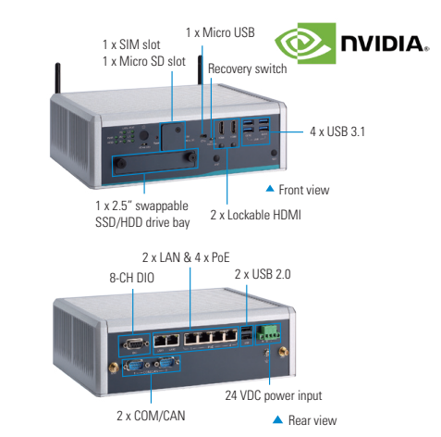

**Introduction**

The AIE900-902-FL adopts the NVIDIA® Jetson AGX Xavier™ platform which has an 8-core NVDIA Carmel ARM® v8.2 (64-bit) processor and 512-Core NVIDIA Volta™ GPU with 64 Tensor cores. The high-performance AI system comes with four PoE ports and two LAN ports for 3D LiDAR and high-speed intelligent video surveillance applications. The AIE900-902-FL is a perfect platform for 3D vision guided robot, autonomous mobile robot (AMR), intelligent video analytics, domain-focused robot assistant, intelligent roadside unit, and more.

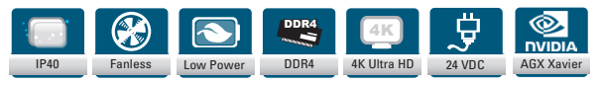

**Features:**

* NVIDIA® Jetson AGX Xavier™ with 512-core Volta GPU with 64 Tensor cores GPU
* High AI computing performance for GPU-accelerated processing
* Ideal for intelligent edge applications, AGV, AMR, and computer vision
* Supports M.2 NVMe PCIe x4 SSD slot
* Wide operating temperature from -30°C to +50°C
* Supports JetPack

**NVIDIA Jetson AGX Xavier:**

* High AI Computing performance for GPU-accelerated processing:
* 8-core NVDIA carmel Arm v8.2 64bit CPU 8MB L2 + 4MB L3
* 512-core NVIDIA Volta GPU with 64 Tensor Cores
* 32GB 256-Bit LPDDR4x onboard
* 32GB eMMC onboard
* Dual NVIDIA deep learning accelerator (NVDLA) engines
* Dual 7-way VLIW vision processor

**Ready for Massive data processing**

* One M.2 key M 2280 with PCIe x4 NVMe SSD slot
* One micro SD slot
* One 2.5’’ SSD/HDD drive bay

**Great Expandability and wireless connectivity**

* One full size PCI express Mini card slot
* One M.2 Key E 2230 slot
* One Sim Slot

**Camera and sensor connectivity**

* Two 10/100/1000 Mbps Ethernet
* Four 10/100/1000 Mbps PoE (max. up to 60 Watts)

**Specifications:**

|  |  |
| --- | --- |
| **CPU Board** | * NVIDIA® Jetson AGX Xavier™ |
| **CPU** | * 8-core Carmel ARM® v8.2 64-bit CPU, 8MB L2 + 4MB L3 |
| **GPU** | * 512-Core NVIDIA Volta™ GPU with 64 Tensor Cores |
| **Chipset** | * SoC integrated |
| **AI Accelerator** | * N/A |
| **System Memory** | * 32GB 256-Bit LPDDR4x onboard |
| **COM** | * 2 x RS-232 default (or 2 x CAN by jumper settings) |
| **USB** | * 2 x USB 3.1 Gen2 * 2 x USB 3.1 Gen1 * 2 x USB 2.0 * 1 x Micro USB |
| **Ethernet** | * 2 x 10/100/1000 Mbps Ethernet (Intel® i210-IT) * 4 x 10/100/1000 Mbps PoE (Intel® i210-IT) |
| **Display** | * 2 x Lockable HDMI 2.0 with 4K2K supported |
| **Digital I/O** | * 1 x 8-CH DI/DO |
| **Audio** | * N/A |
| **Storage** | * Onboard 32GB eMMC (via Jetson AGX Xavier™) * 1 x M.2 Key M 2280 with PCIe x4 NVMe SSD slot * 1 x Micro SD slot * 1 x 2.5" SSD/HDD drive bay |
| **Expansion** | * 1 x Full-size PCI Express Mini Card slot (USB + PCI Express signal) * 1 x M.2 Key E 2230 slot * 1 x SIM slot |
| **Others** | * 4 x SMA-type antenna connector |
| **Power Supply** | * 1 x 24 VDC power input connector * 24 VDC (9 to 36 VDC without PoE feature by option) |
| **Operating Temperature** | * -30°C to +50°C (-22°F to +122°F) |
| **Dimensions (W x D x H)** | * 239 x 185.3 x 79.4 mm (9.41" x 7.3" x 3.13") |
| **Weight (net/gross)** | * 2.8kg (6.17lb)/3.45kg (7.61lb) |
| **EOS Support** | * Linux Ubuntu 18.04 |
| **Mounting** | * Wall mount kit * DIN-rail kit * VESA mount kit |
| **Weight (net/gross)** | * 2.8kg (6.17lb)/3.45kg (7.61lb) |
| **Certifications** | * CE, FCC Class A |

**Optional:**

* Wall mount kit
* DIN-rail kit
* VESA mount kit
* M.2 NVMe SSD 128GB or above
* 2.5" SATA SSD 128GB or above
* LTE module kit
* Wi-Fi module kit
* 24V/230W adapter
* Power cord

**Power Protection:**

* DC Version
* OVP (over voltage protection)
* OCP (over current protection)
* UVP (under voltage protection)
* Reserve protection